**Producer Consumer EC2 Hands-on**

**Create EC2 instance with same VPC, IP (Enabled) and IAM (Allow MSK)**

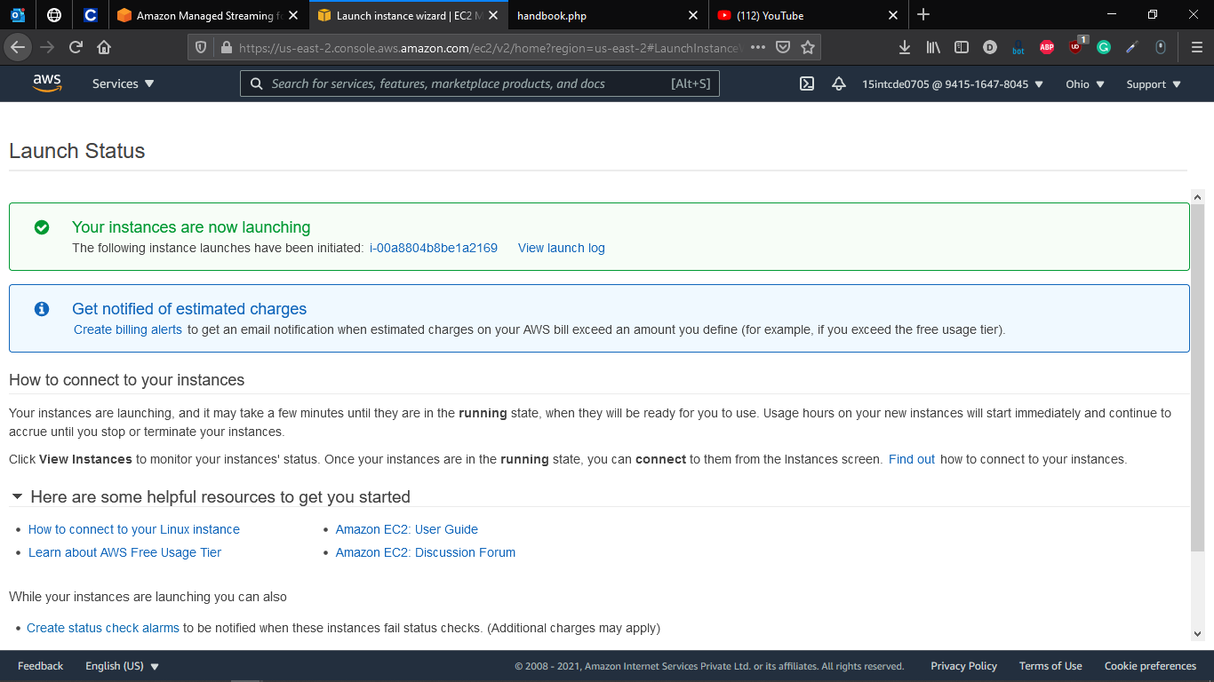

**Connect to Instance and Install Java in it**

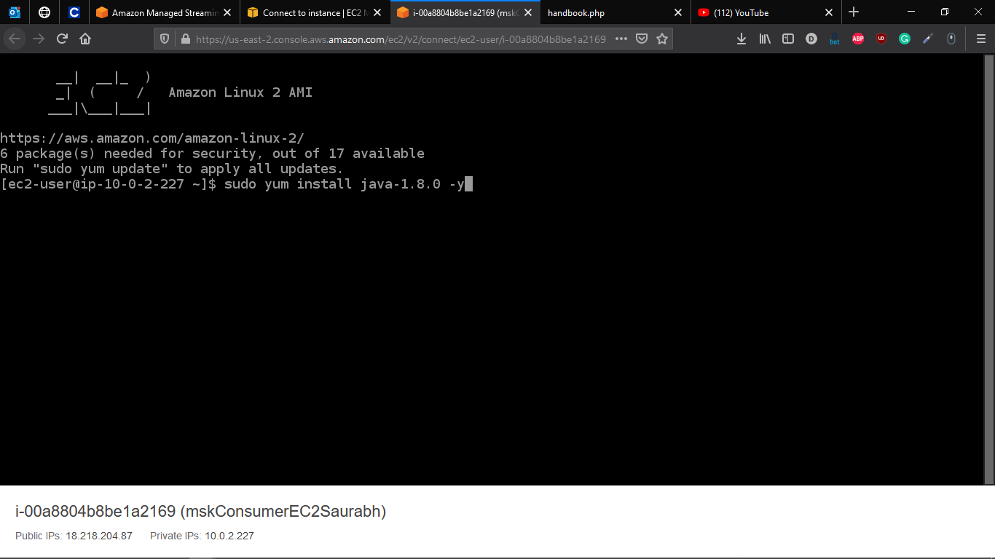

**Getting Apache Kafka (make security group allow all ip – inbound rule)**

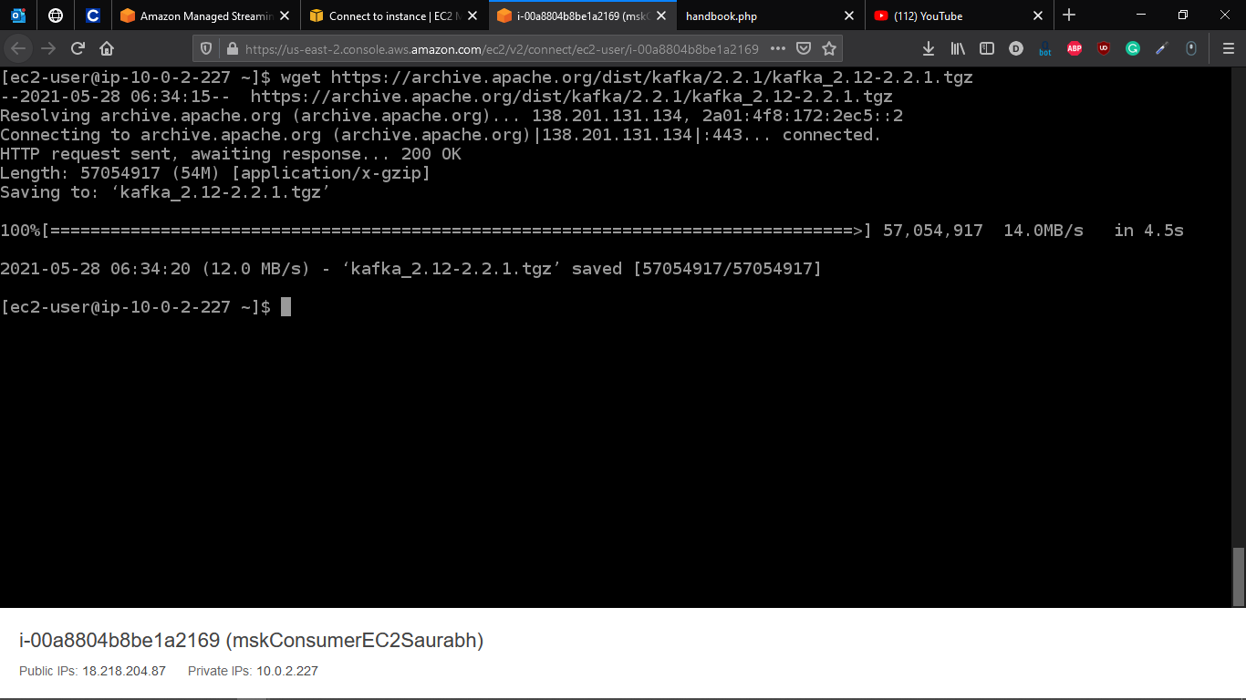

**Extracting the Apache Kafka File**

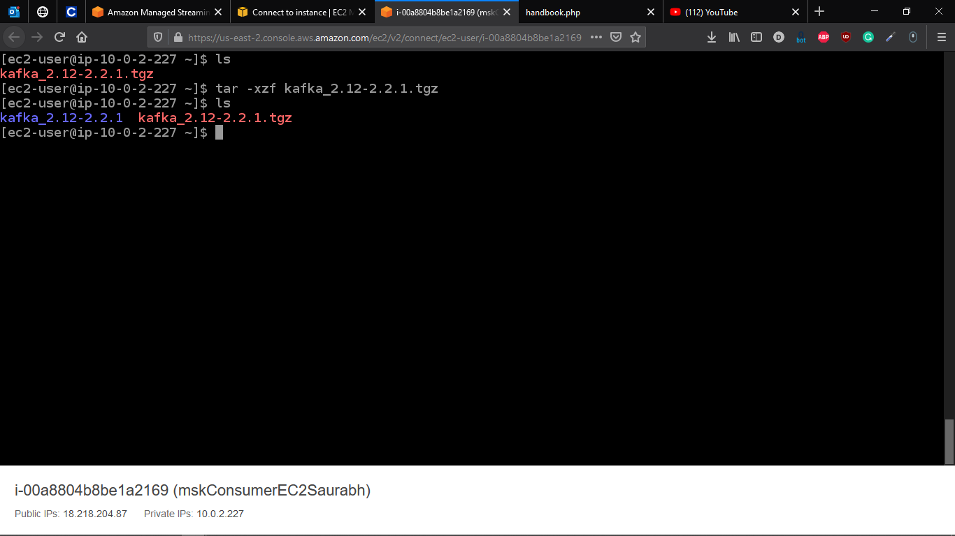

**Set Kafka Path to Bin Folder** export PATH=$PATH:/home/ec2-user/kafka_2.12-2.2.1/bin

**Select Your Created Cluster (MSK Cluster)**

aws kafka describe-cluster --cluster-arn arn:aws:kafka:us-east-2:941516478045:cluster/mskClusterSaurabh/2aed5f10-e9b8-4495-a0c3-8f9f97869fc4-3 --region us-east-2

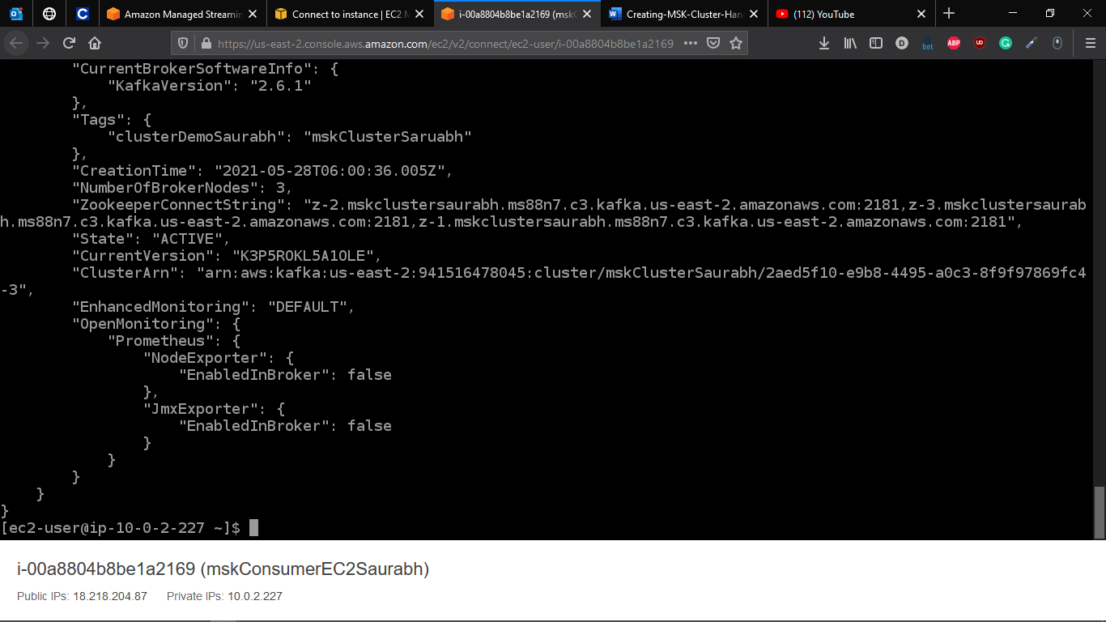

**Locate ZOOKEEPER value for the Cluster and then execute following steps**

a. --Zookeeper specifies the zookeeper connectionstring.

b. --topic specifies the name of the topic to be created.

c. –partitions specified the number of partitions to be created in the topic

d. –replication-factor specified the replication factor of the broker.

Final Command for My Cluster will be

kafka-topics.sh --zookeeper z-2.mskclustersaurabh.ms88n7.c3.kafka.us-east-2.amazonaws.com:2181,z-3.mskclustersaurabh.ms88n7.c3.kafka.us-east-2.amazonaws.com:2181,z-1.mskclustersaurabh.ms88n7.c3.kafka.us-east-2.amazonaws.com:2181 --partitions 3 --replication-factor 1 --topic demo-topic --create

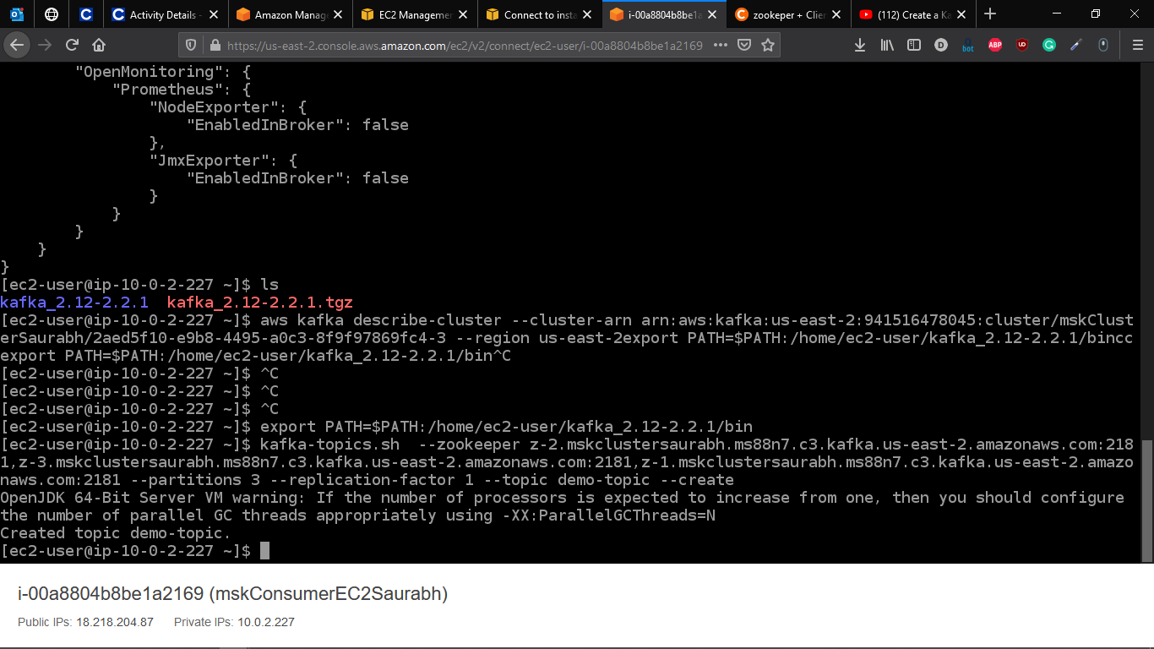

**Go To usr/lib/jvm copy java jdk folder name**

java-1.8.0-openjdk-1.8.0.282.b08-1.amzn2.0.1.x86_64

**Now Go to Home and user and copy the folder to the kafka place**

cp /usr/lib/jvm/ java-1.8.0-openjdk-1.8.0.282.b08-1.amzn2.0.1.x86_64/jre/lib/security/cacerts /tmp/kafka.client.truststore.jks

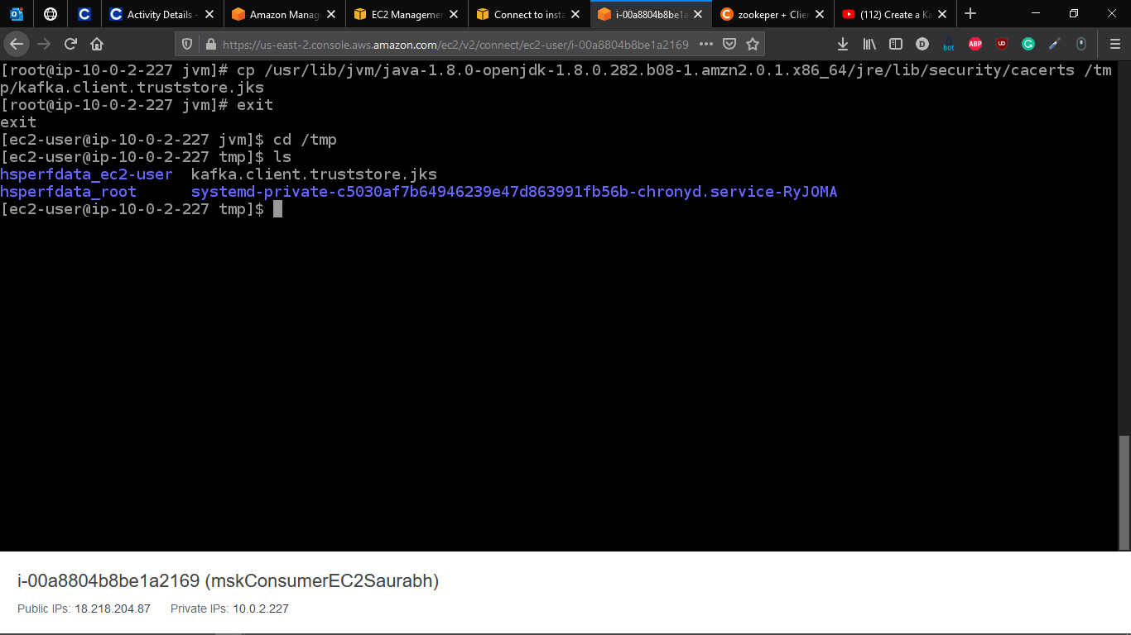

22. Create a file named client.properties inside this folder by using the text editor vim

23. Type vim client.properties in the terminal

24. Press i for insert inside the editor and type the following lines of code

security.protocol=SSL

ssl.truststore.location=/tmp/kafka.client.truststore.jks

25. Press esc and type :wq to save and exit from the editor

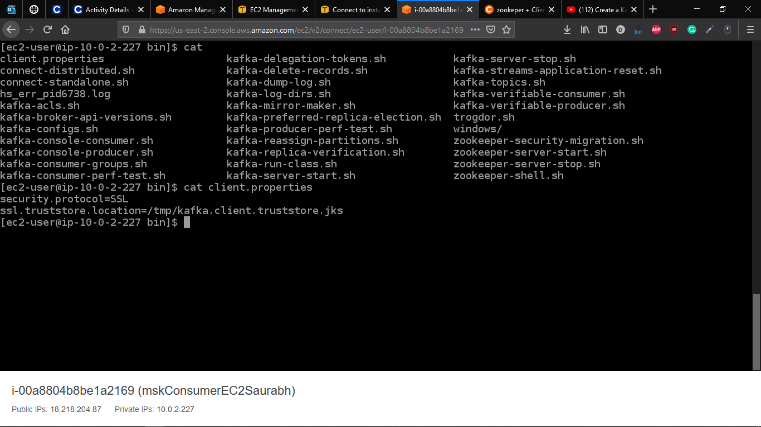

**Now we have to get bootstrap brokers for the Kafka Client**

aws kafka get-bootstrap-brokers --region us-east-2 --cluster-arn arn:aws:kafka:us-east-2:941516478045:cluster/mskClusterSaurabh/2aed5f10-e9b8-4495-a0c3-8f9f97869fc4-3

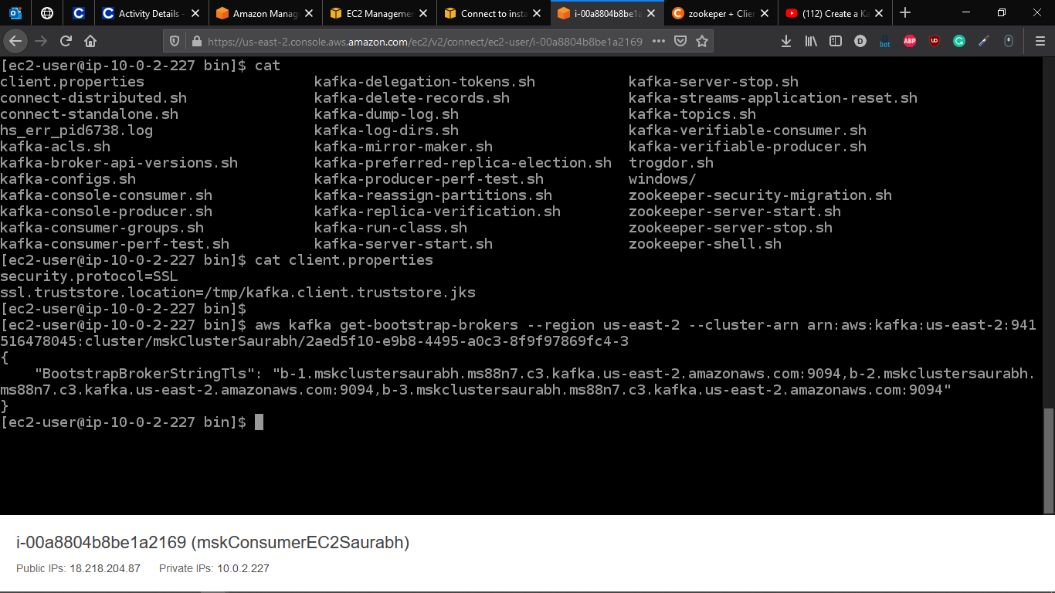

**Now we need to create producer for Kafka**

kafka-console-producer.sh --broker-list b-1.mskclustersaurabh.ms88n7.c3.kafka.us-east-2.amazonaws.com:9094,b-2.mskclustersaurabh.ms88n7.c3.kafka.us-east-2.amazonaws.com:9094,b-3.mskclustersaurabh.ms88n7.c3.kafka.us-east-2.amazonaws.com:9094 --producer.config client.properties --topic demo-topic

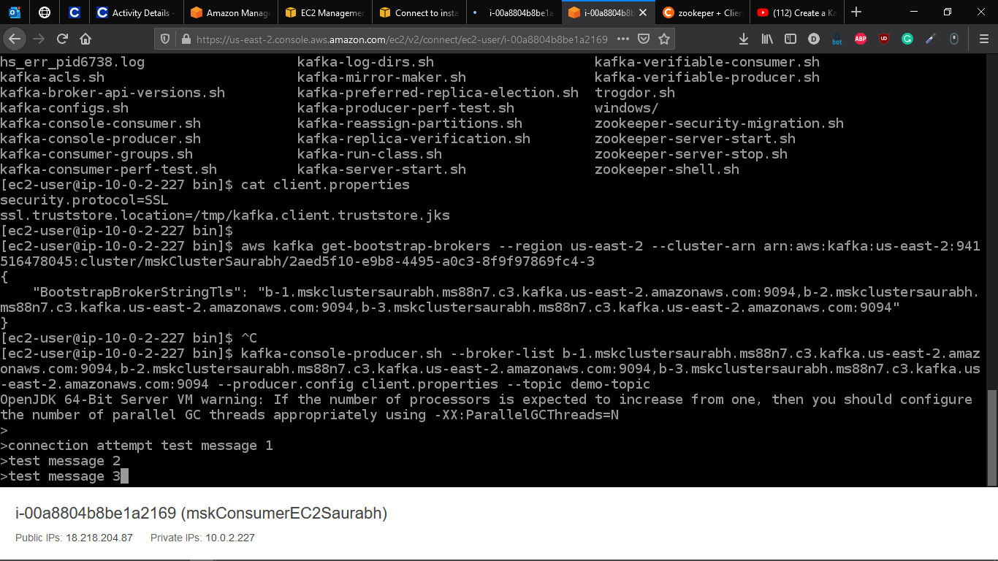

**Sending messages for Producer, Now open a new terminal to receive the producer sended messages**

Set the path by issuing the command below

export PATH=$PATH:/home/ec2-user/kafka_2.12-2.2.1/bin

Move to the folder kafka_2.12-2.2.1/bin by issuing

cd kafka_2.12-2.2.1/bin

**Now we have to create Consumer in the new terminal**

kafka-console-consumer.sh --bootstrap-server b-1.mskclustersaurabh.ms88n7.c3.kafka.us-east-2.amazonaws.com:9094,b-2.mskclustersaurabh.ms88n7.c3.kafka.us-east-2.amazonaws.com:9094,b-3.mskclustersaurabh.ms88n7.c3.kafka.us-east-2.amazonaws.com:9094 --topic demo-topic --consumer.config client.properties --from-beginning

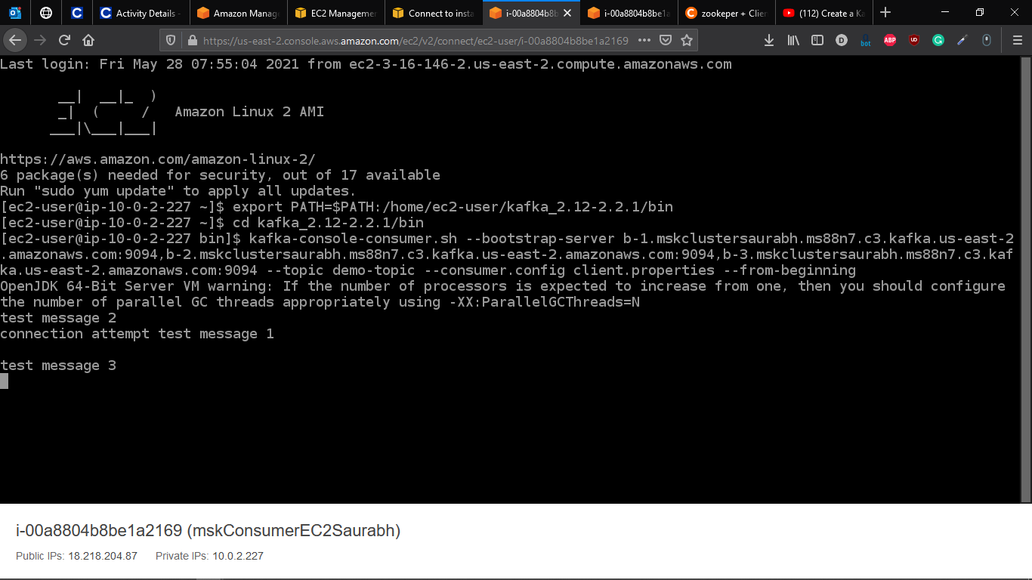

Msgs Received on the consumer end

